Feras Alsinan 202021580.  
  
Mood Board.

Site type: business: Drawings request  
  
Colors:  
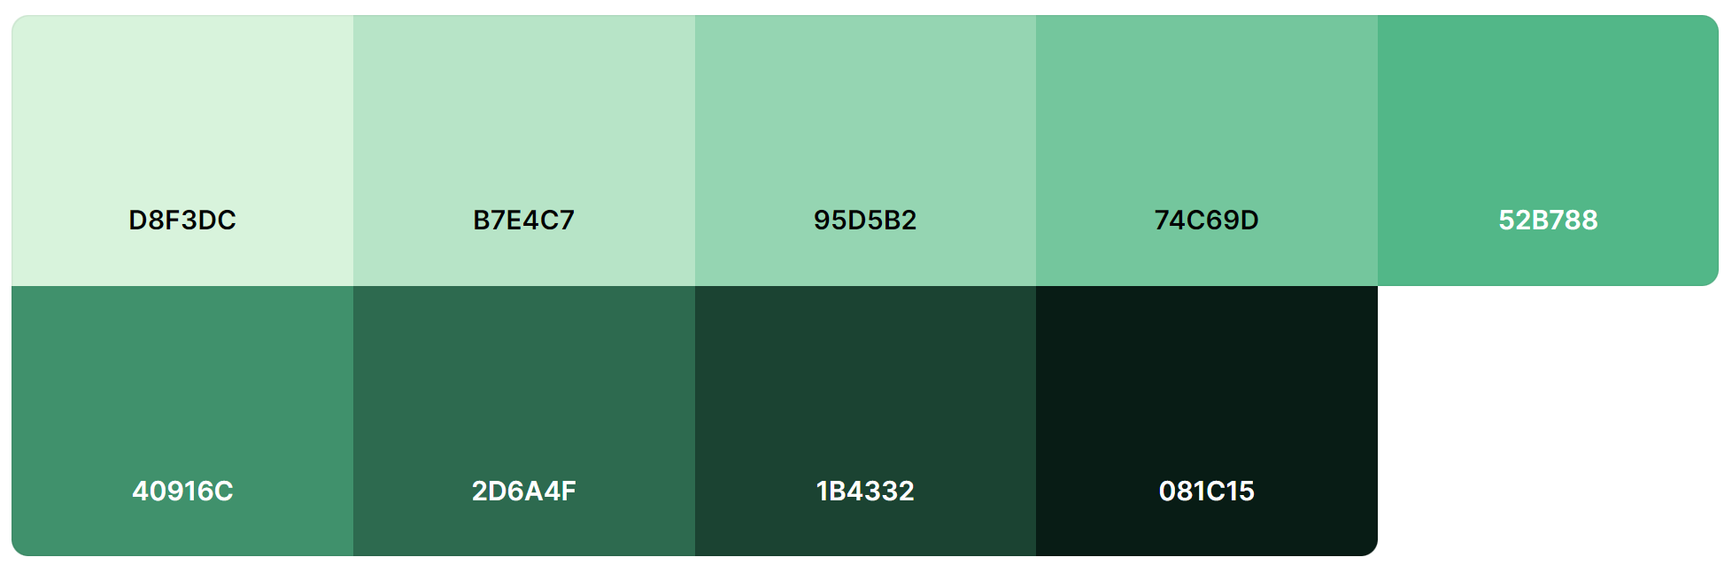

+ White for the background or text.  
Link for copy-paste: <https://coolors.co/palette/d8f3dc-b7e4c7-95d5b2-74c69d-52b788-40916c-2d6a4f-1b4332-081c15>

Pictures... and some ideas...

